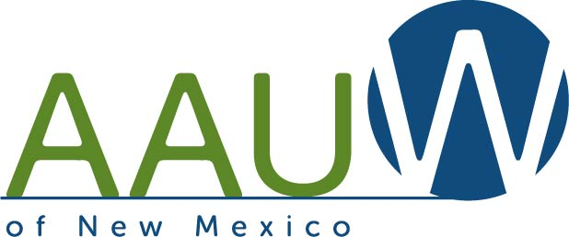
Recognizes
The New Mexico On-Line Branch
For increasing membership by 7.69% since 02/01/ 2012
Date: April 20, 2013 By Co-Membership Chairs: Sylvia Fink and Natalie Markin

